**Step-by-step to configure your deep learning environment**

This document explains how to install deep learning environment on your computer.

1. Download **Anaconda** distribution from <https://www.anaconda.com/distribution/> and choose your appropriate system environment to install it. After this, you can operate Python and get an **ANACONDA NAVIGATOR** application, from which you can see **Jupyter Notebook** application.
2. After opening **terminal window** in your computer, you can install **Tensorflow** by the **terminal window**:

# **Current release for CPU-only**

pip install tensorflow

1. Download **IDE environment**, e.g., PyCharm in our course.

* You can download **PyCharm** from [https://www.jetbrains.com/pycharm/download/#section=**linux**](https://www.jetbrains.com/pycharm/download/#section=linux)

Or

[https://www.jetbrains.com/pycharm/download/#section=**windows**](https://www.jetbrains.com/pycharm/download/#section=windows)

* After install on your computer, you may find the problem as follows:

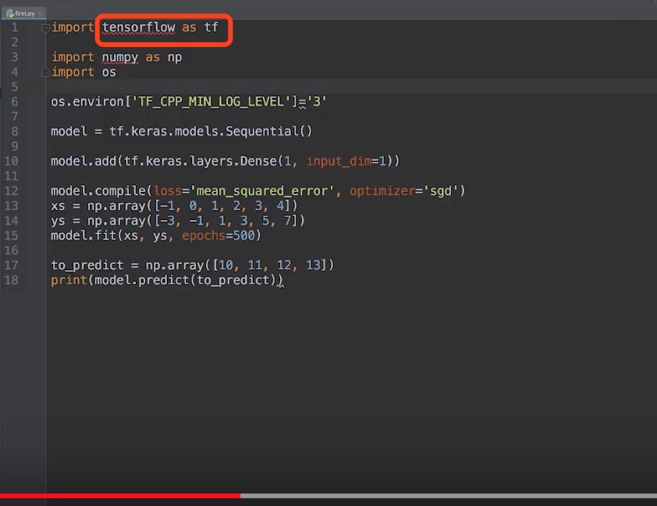

* It denotes that Project interpreter is not appropriate, so you need to find the **project interpreter** from **Preferences,**

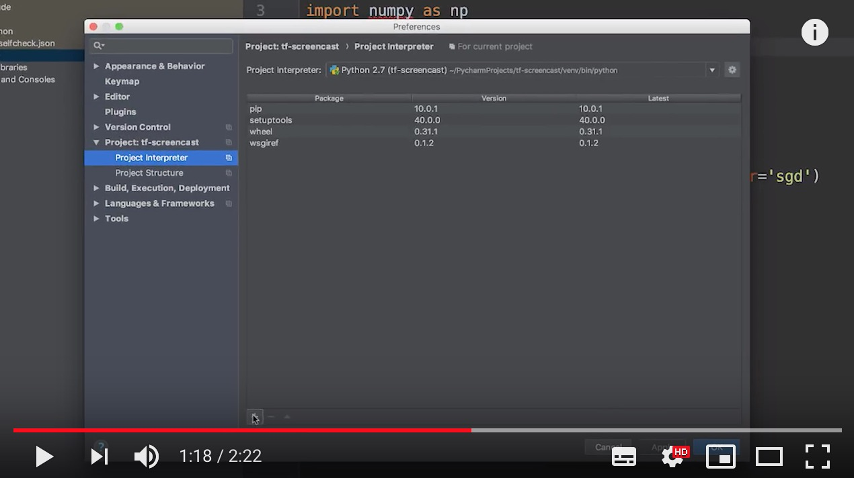

And then type **tensorflow** to search before pressing the install button.

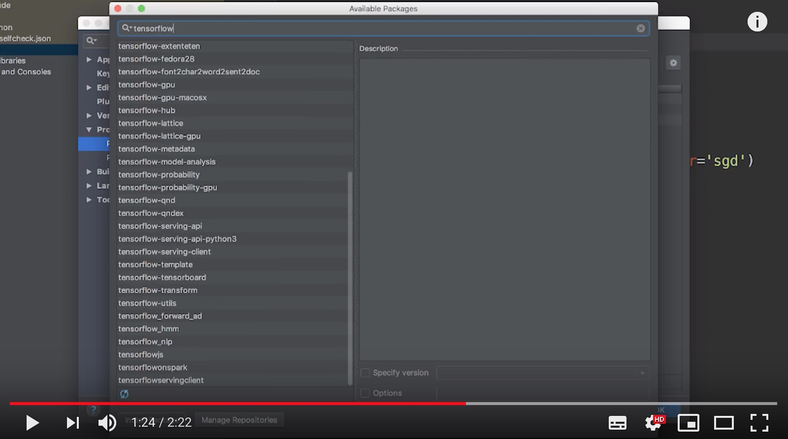

**Well done!** Now please use your PyCharm to run the following example.

Let’s start your first deep learning program.

